# **Monitoring using Prometheus and Grafana on AWS EC2**

### **Agenda**

1. Prometheus Architecture
2. Install Prometheus and configure Prometheus to monitor itself
3. Install Node Exporter on other EC2 Instances
4. Configure Prometheus for the EC2 Instance
5. EC2 Service Discovery for Prometheus
6. Install Grafana

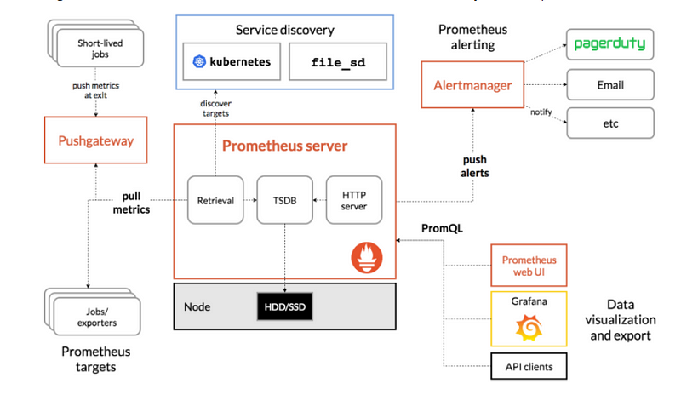

### **Install Prometheus**

./install-prometheus.sh

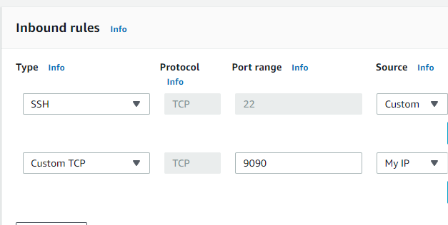

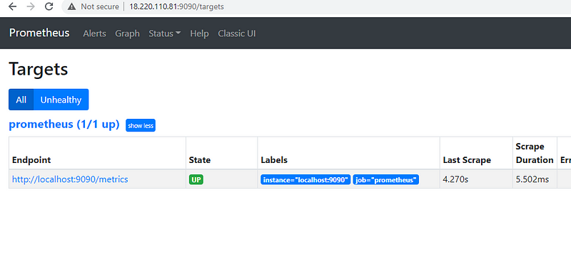

#### **Create Target EC2 Instances**

Configure the security group on EC2 Instance which you want to monitor and where you will install Node Exporter as shown below:

./install-node-exporter.sh

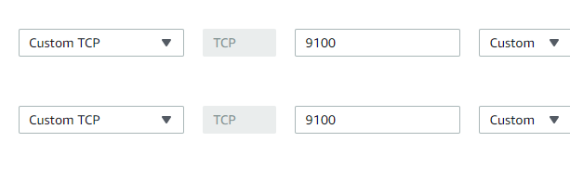

**In Monitoring-Server**

### **Configure Prometheus for the Nodes**

Login to the Prometheus server and edit the file

/etc/prometheus/prometheus.yml

global:

scrape_interval: 15s

external_labels:

monitor: 'prometheus'

scrape_configs:

- job_name: 'node_exporter'

static_configs:

- targets: ['18.219.214.162:9100']

Restart the Prometheus Service

sudo systemctl restart prometheus

sudo systemctl status prometheus

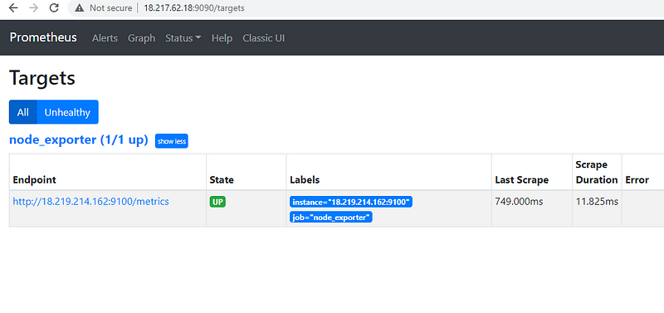

### **Install Grafana**

./install-grafana.sh

Make sure that port 3000 is open for this instance.

[http://yourip:3000](http://youip:3000/)

Login with username : admin and password admin

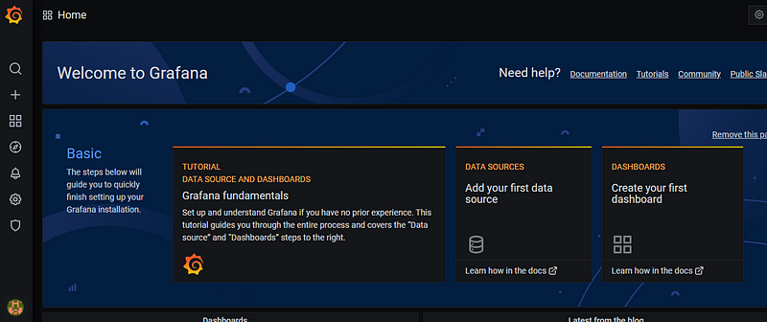

Add Prometheus DataSource

Click on Setting ->datasources

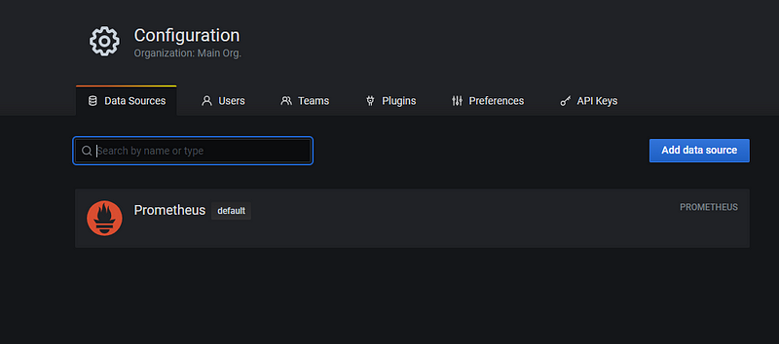

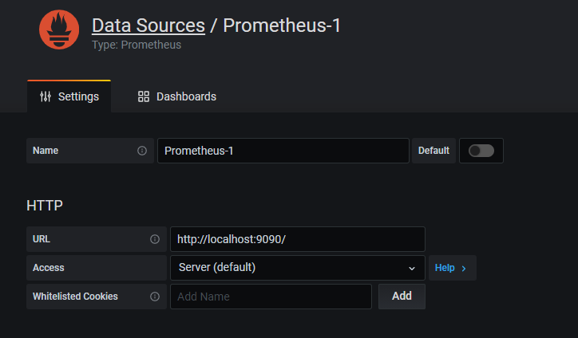

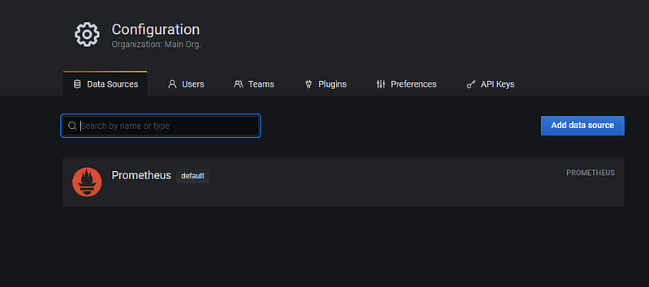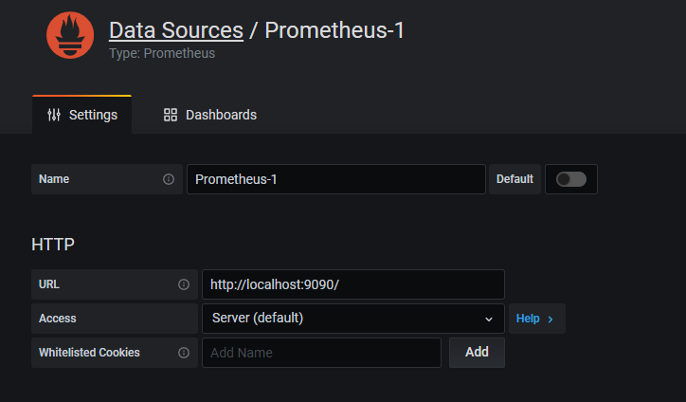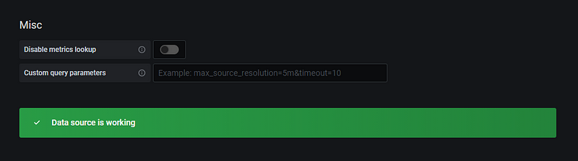

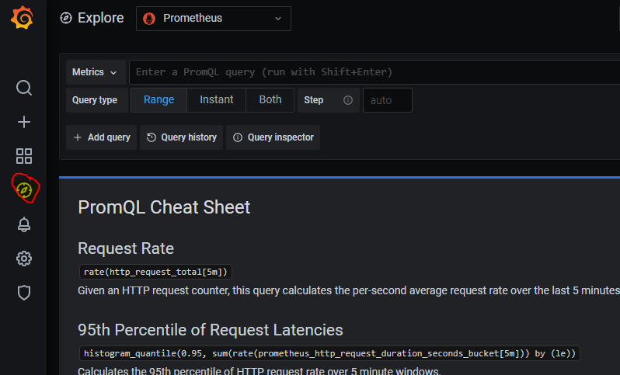

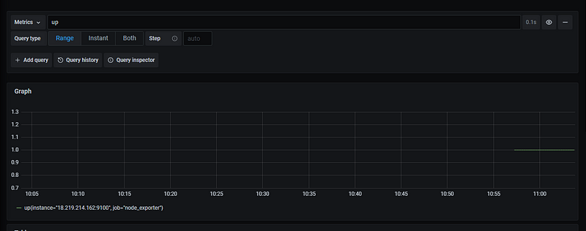

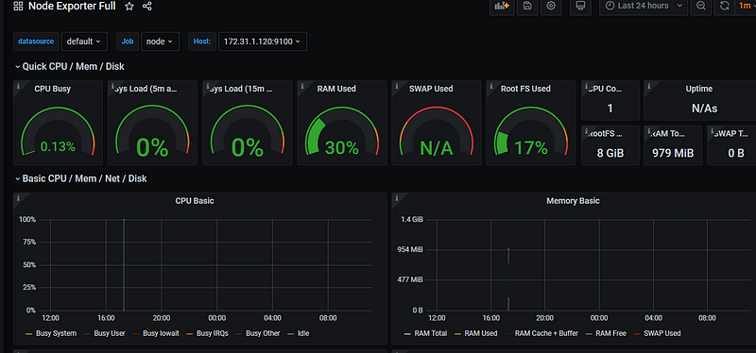

### **Prometheus Service Discovery on EC2 Instance**

Sudo -i

cd /etc/prometheus/

nano prometheus.yml

global:

scrape_interval: 15s

external_labels:

monitor: 'prometheus'

scrape_configs:

- job_name: 'node'

ec2_sd_configs:

- region: us-east-2

access_key: yourkey

secret_key: yourkey

port: 9100

Specify the AWS region and use IAM user API key which has EC2ReadyOnlyAccess

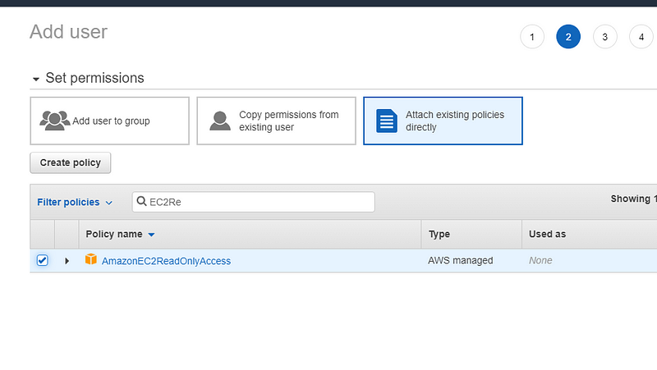

sudo systemctl restart prometheus

sudo systemctl status prometheus